**Installation steps :**

1. Create a DB2 schema using below command

CREATE DATABASE SIDBGD AUTOMATIC STORAGE YES USING CODESET UTF-8 TERRITORY DEFAULT COLLATE USING SYSTEM PAGESIZE 32768

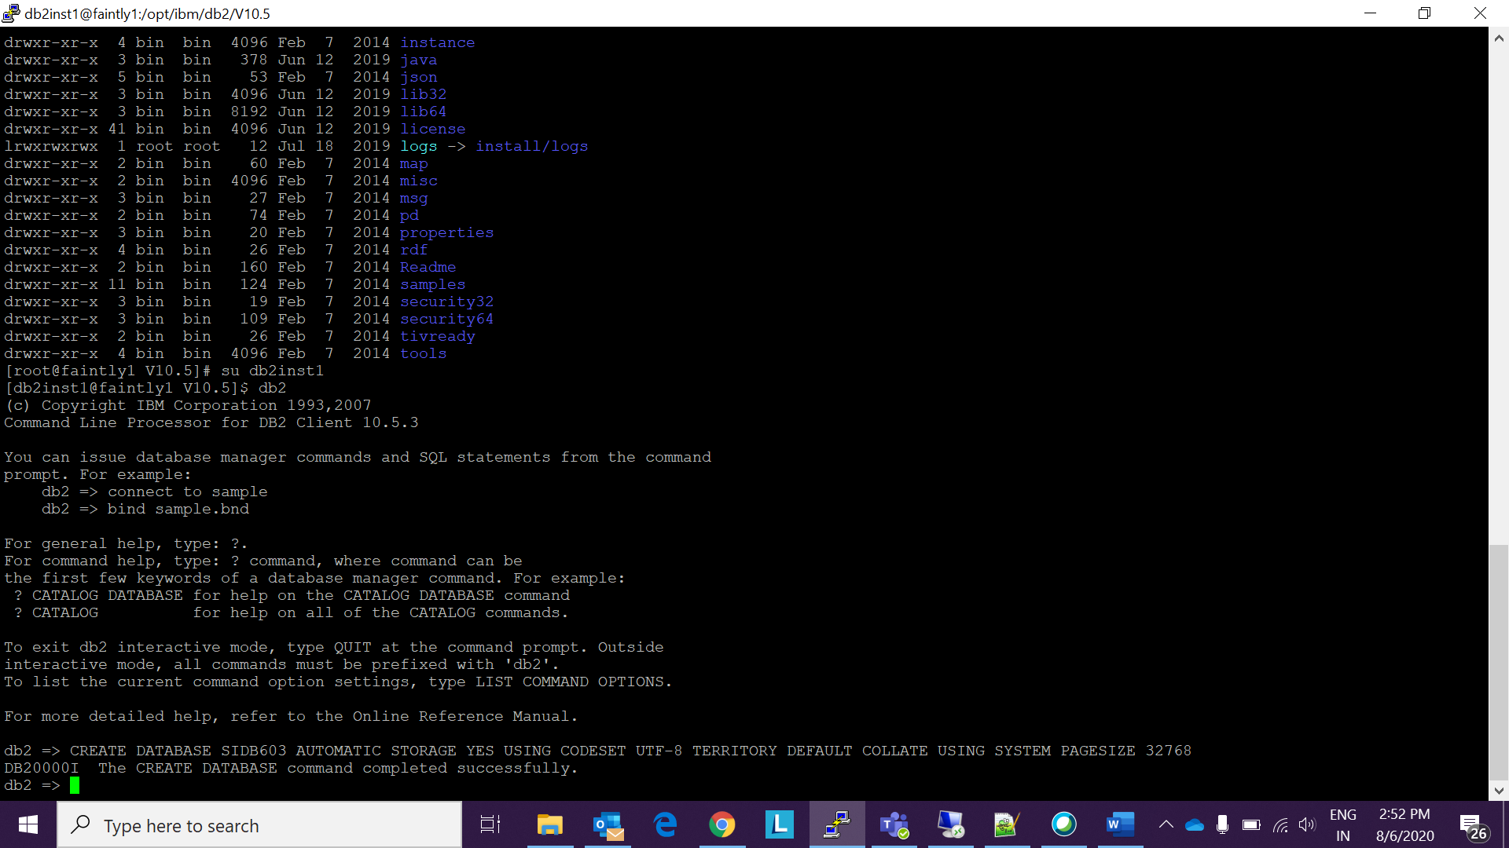

+++++++++++++++++++++++++++++++++++++++++++++++++++++++++++++++++++++++++++++++++++++

1. Be ready with the Installables and launch the IBM Installation Manager

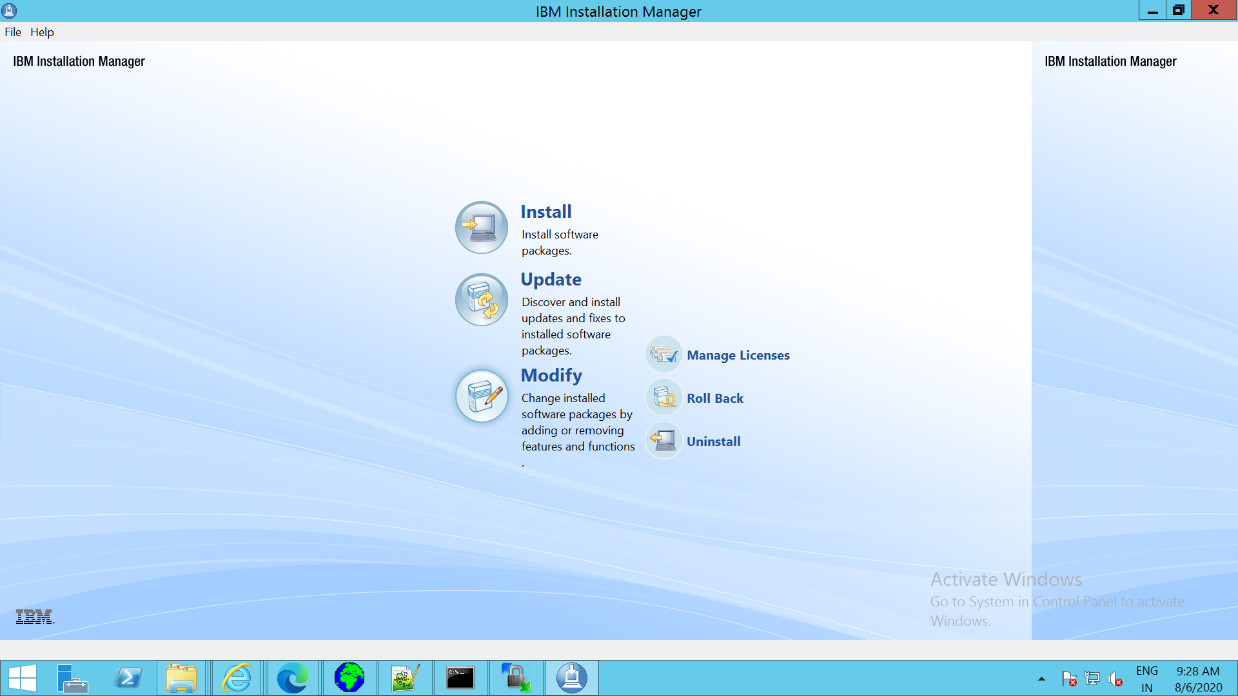

+++++++++++++++++++++++++++++++++++++++++++++++++++++++++++++++++++++++++++++++++++++

1. Click on the file on IM and choose Preferences

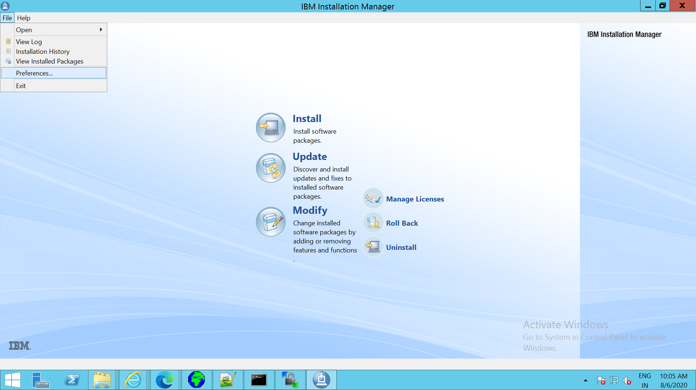

+++++++++++++++++++++++++++++++++++++++++++++++++++++++++++++++++++++++++++++++++++++

1. Add the repository as shown below

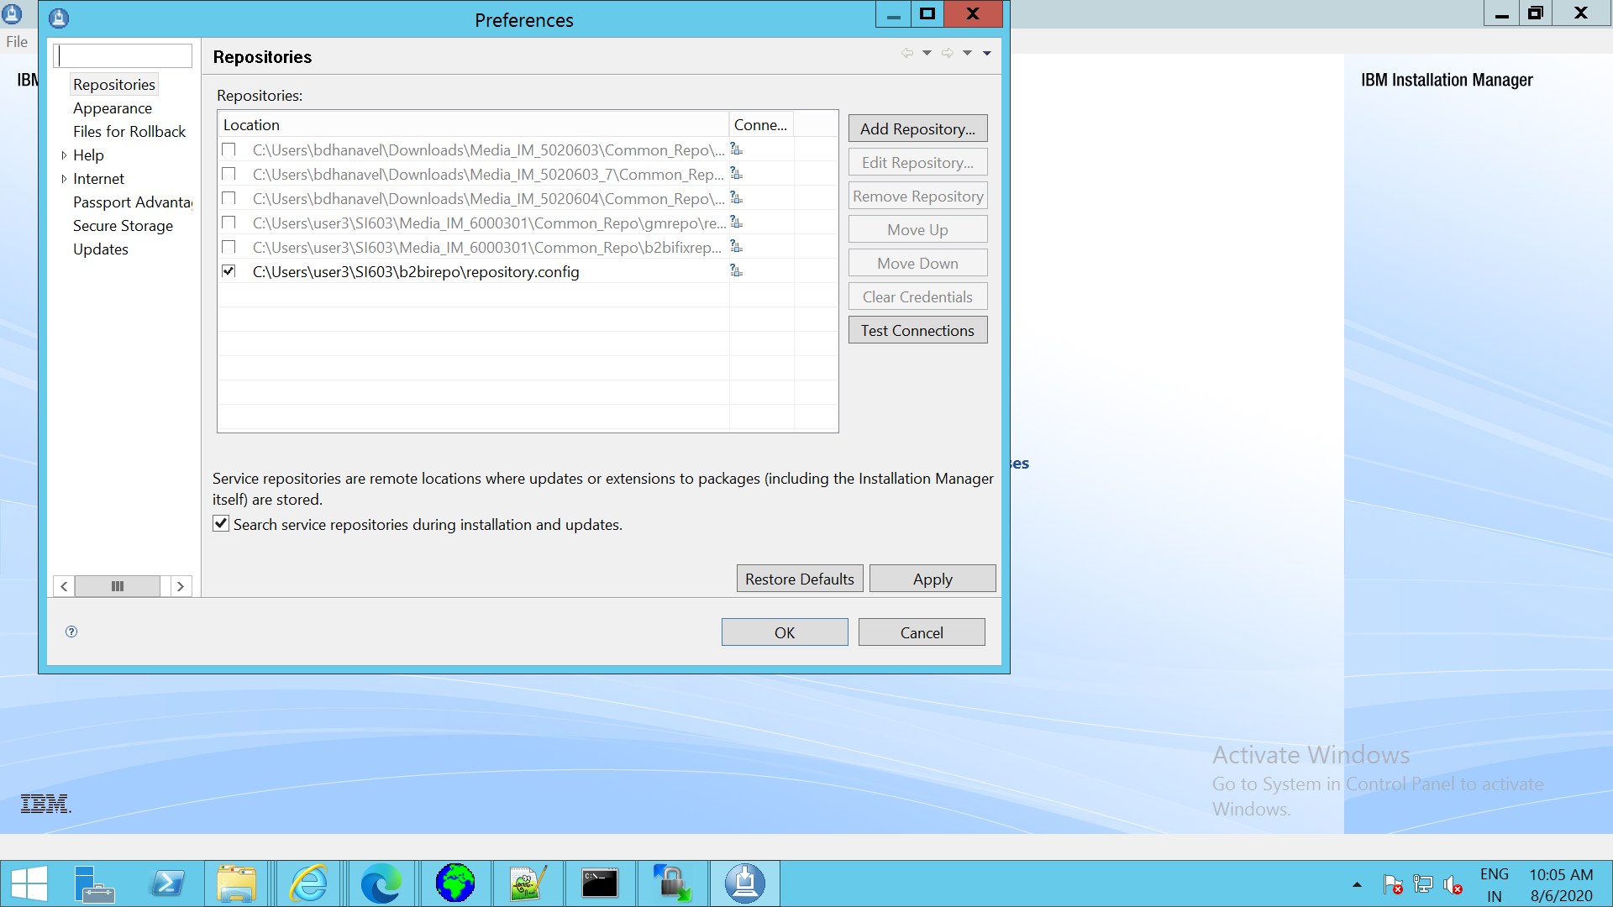

+++++++++++++++++++++++++++++++++++++++++++++++++++++++++++++++++++++++++++++++++++++

1. Apply and save and click on the Install button and choose the version which you want to install

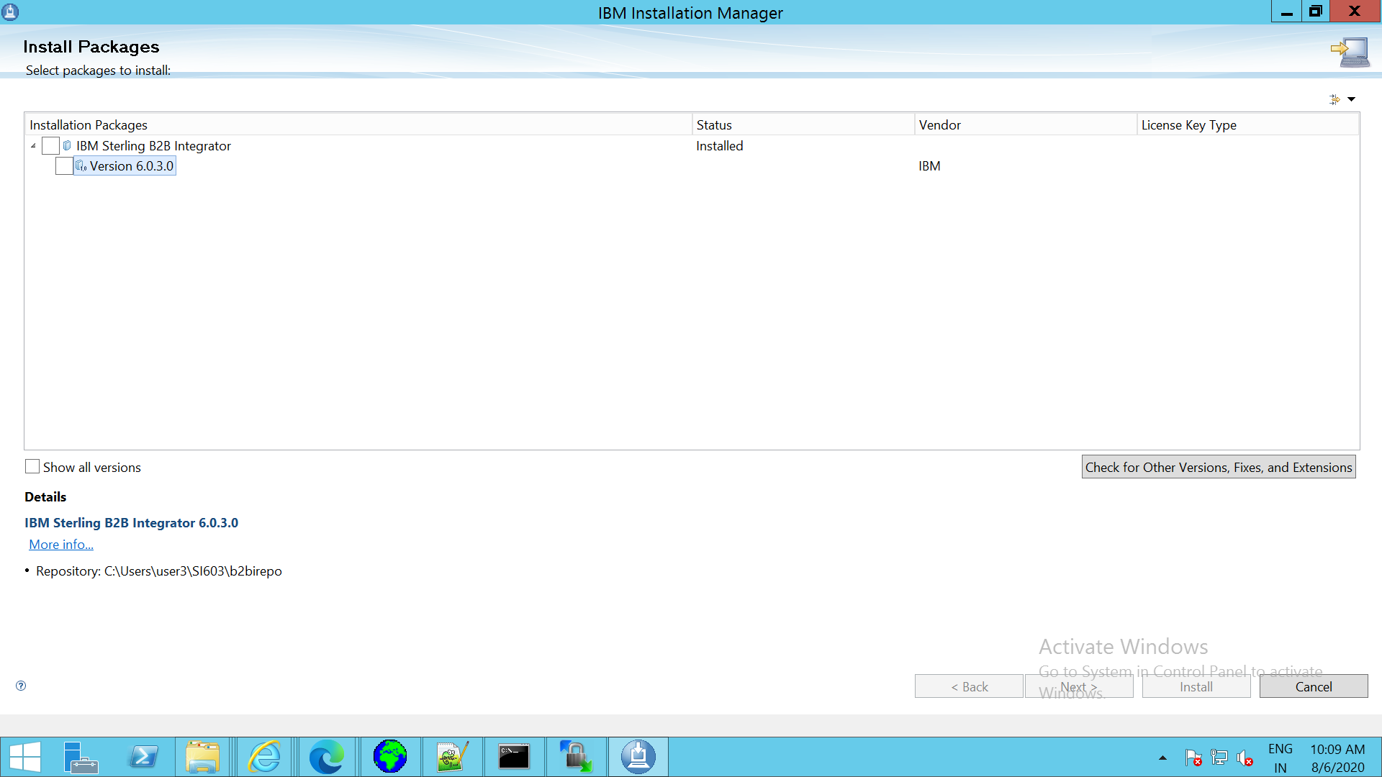

++++++++++++++++++++++++++++++++++++++++++++++++++++++++++++++++++++++++++++++++++++

1. Accept the License agreement and click on next

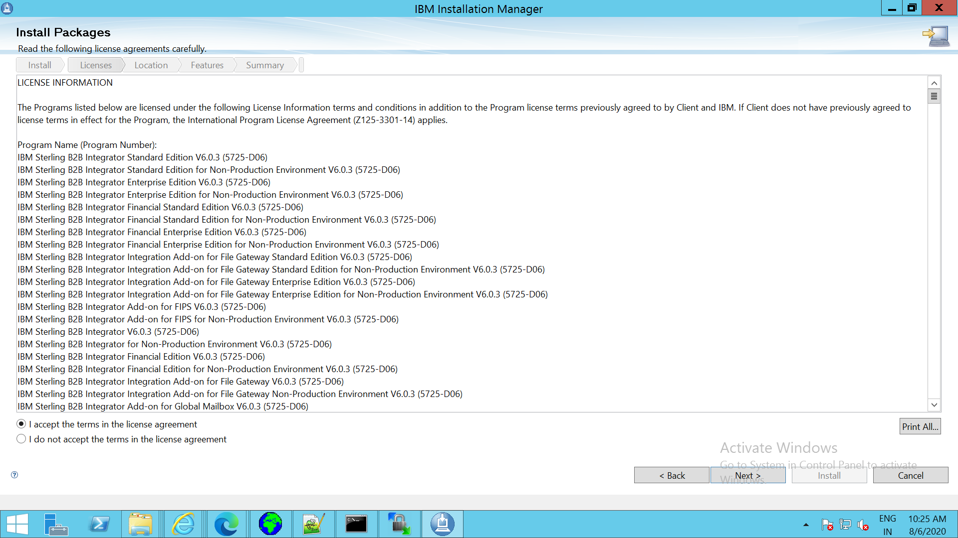

+++++++++++++++++++++++++++++++++++++++++++++++++++++++++++++++++++++++++++++++++++++

1. Give the installation directory

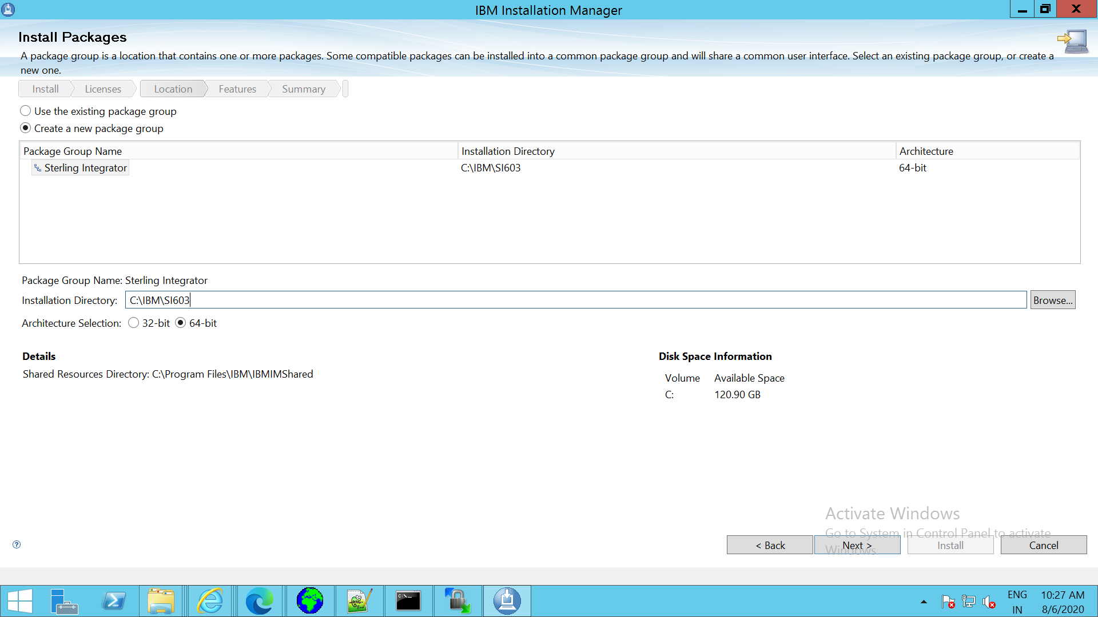

++++++++++++++++++++++++++++++++++++++++++++++++++++++++++++++++++++++++++++++++++++

8)Choose SI and SF as shown below

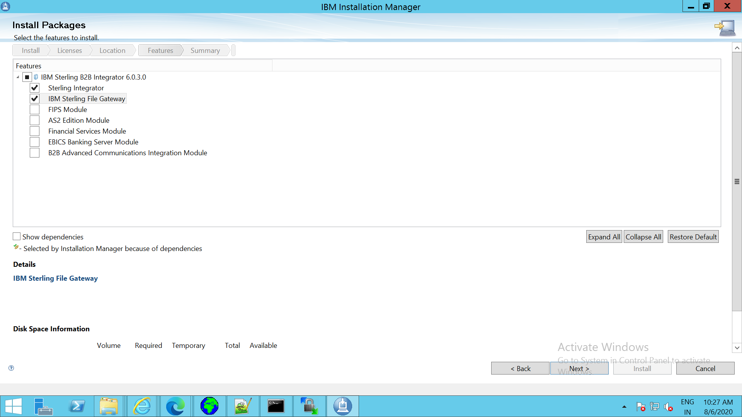

+++++++++++++++++++++++++++++++++++++++++++++++++++++++++++++++++++++++++++++++++++++

1. Give JDK path

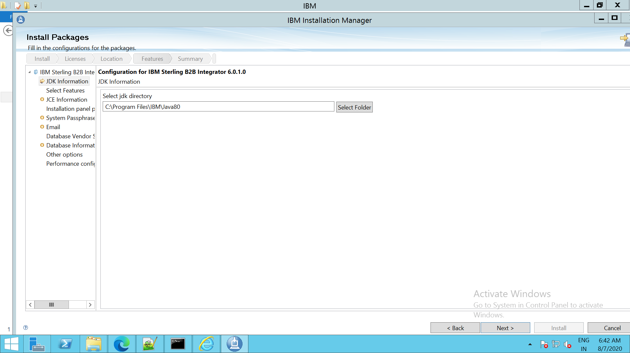

+++++++++++++++++++++++++++++++++++++++++++++++++++++++++++++++++++++++++++++++++++++

1. Choose the JCE file which is Unrestricted PolicyFile

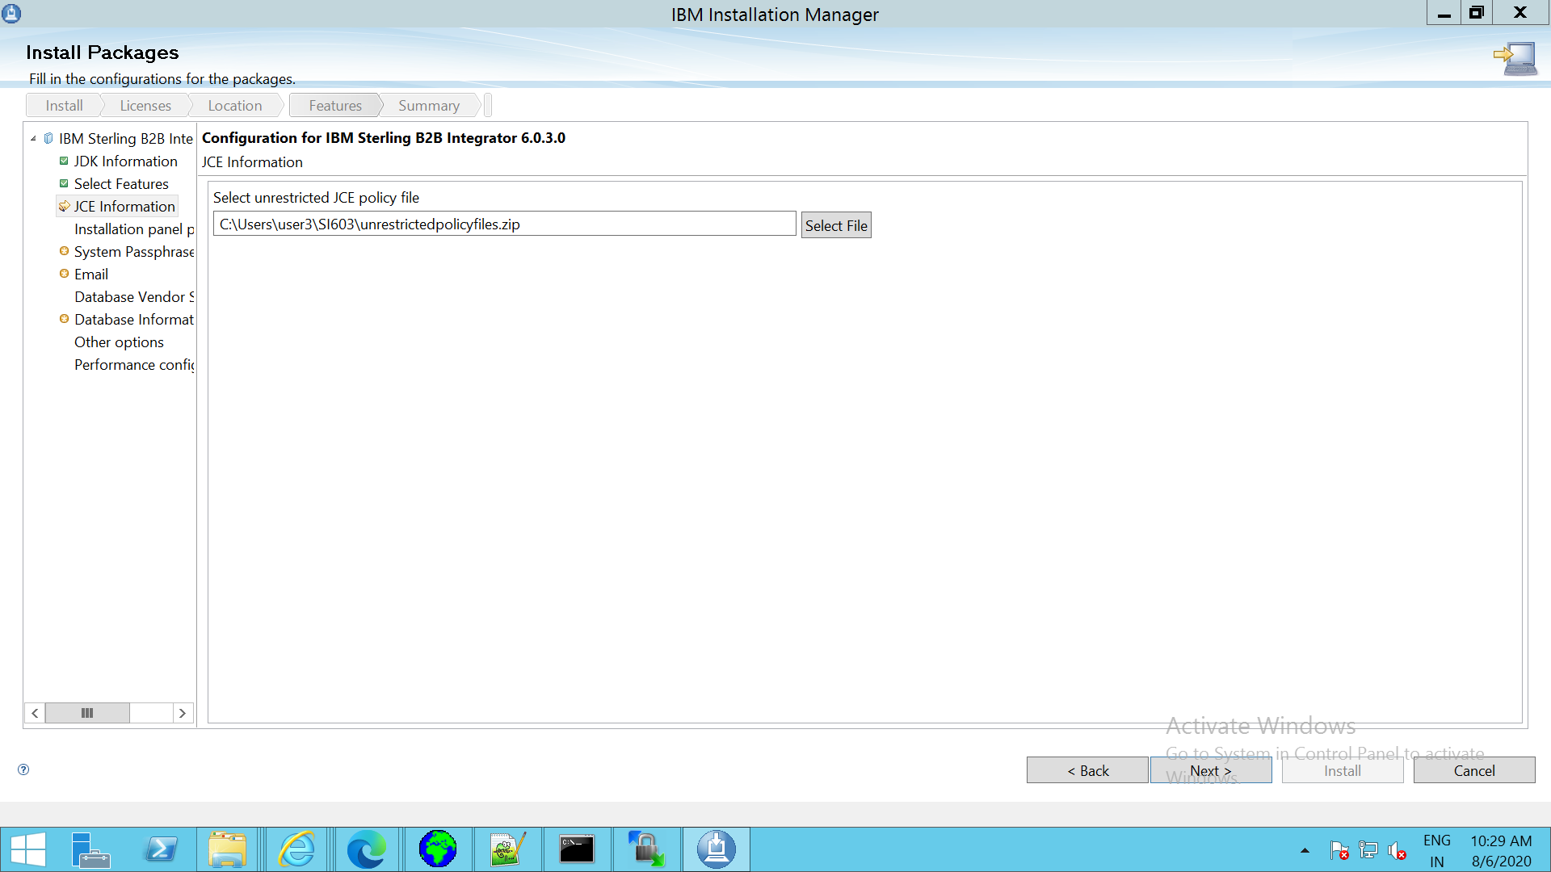

+++++++++++++++++++++++++++++++++++++++++++++++++++++++++++++++++++++++++++++++++++

1. Enter the IP or Host address and Port

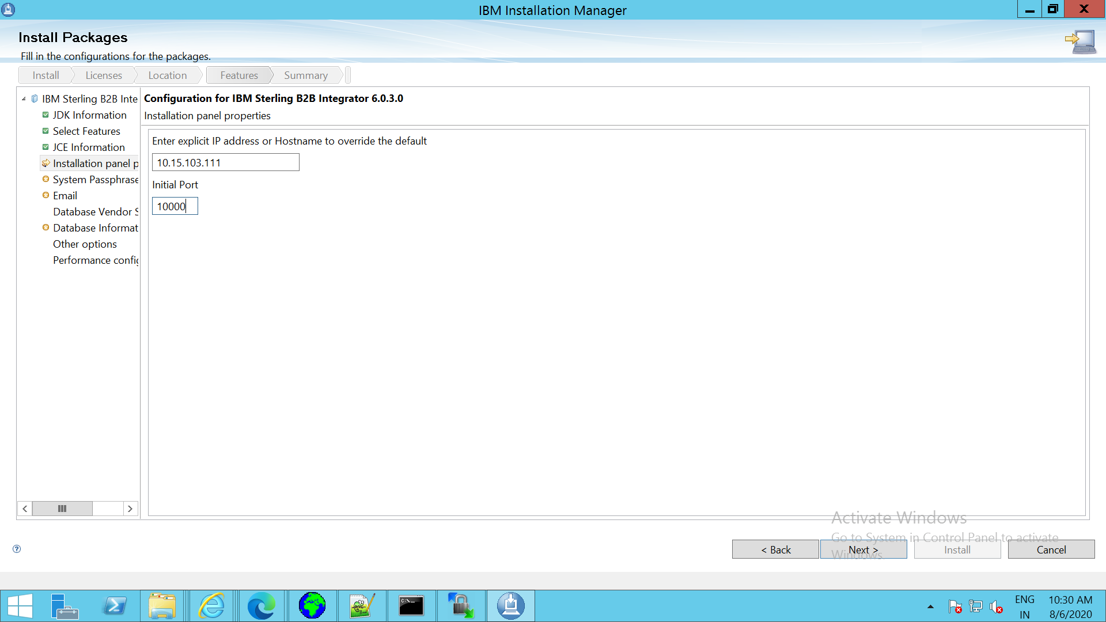

+++++++++++++++++++++++++++++++++++++++++++++++++++++++++++++++++++++++++++++++++++

1. Give the Passphrase

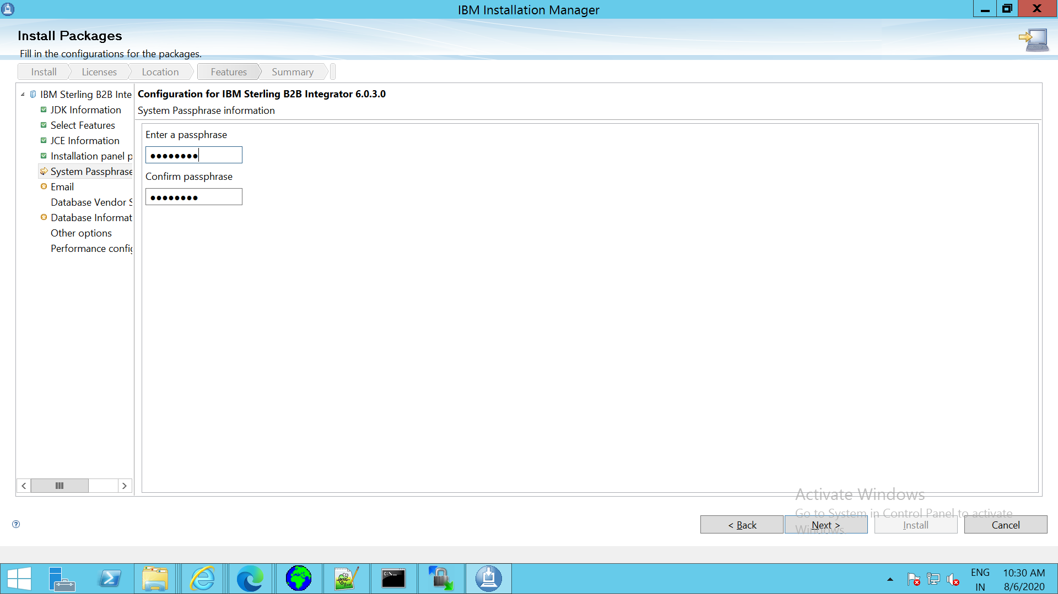

++++++++++++++++++++++++++++++++++++++++++++++++++++++++++++++++++++++++++++++++++

1. Enter email id and the SMTP IP

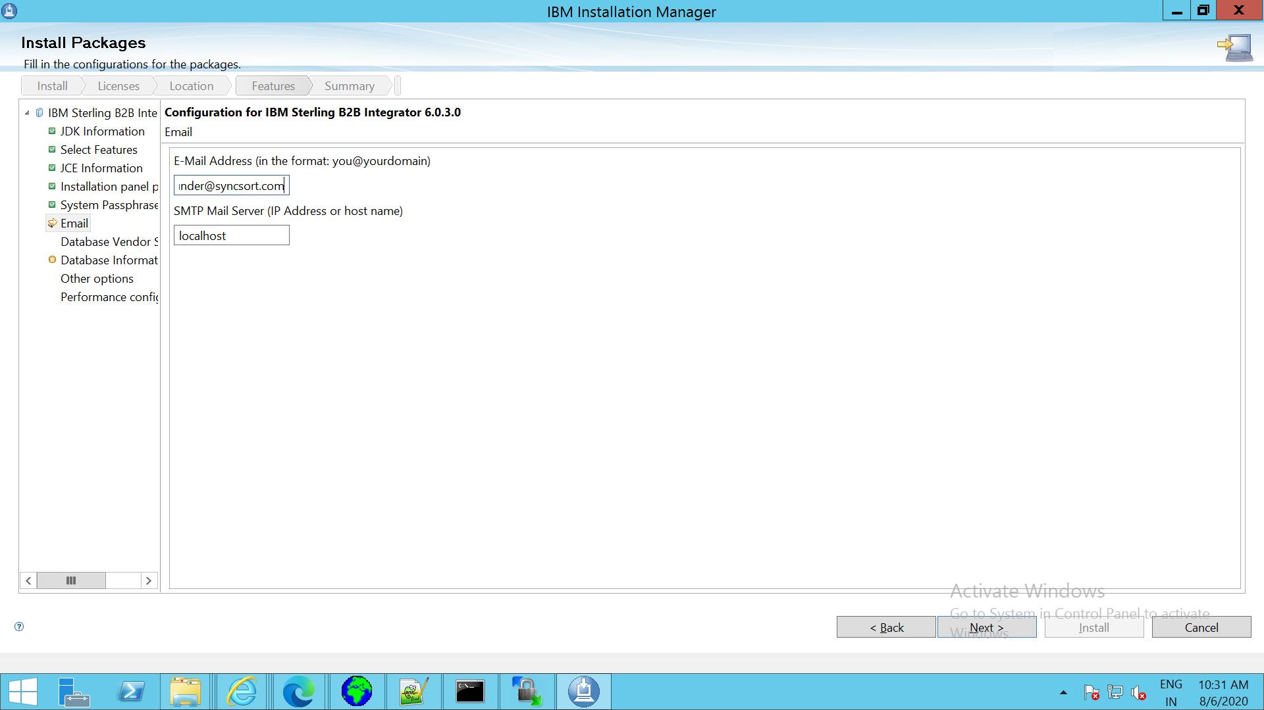

++++++++++++++++++++++++++++++++++++++++++++++++++++++++++++++++++++++++++++++++++++

1. Choose the DB

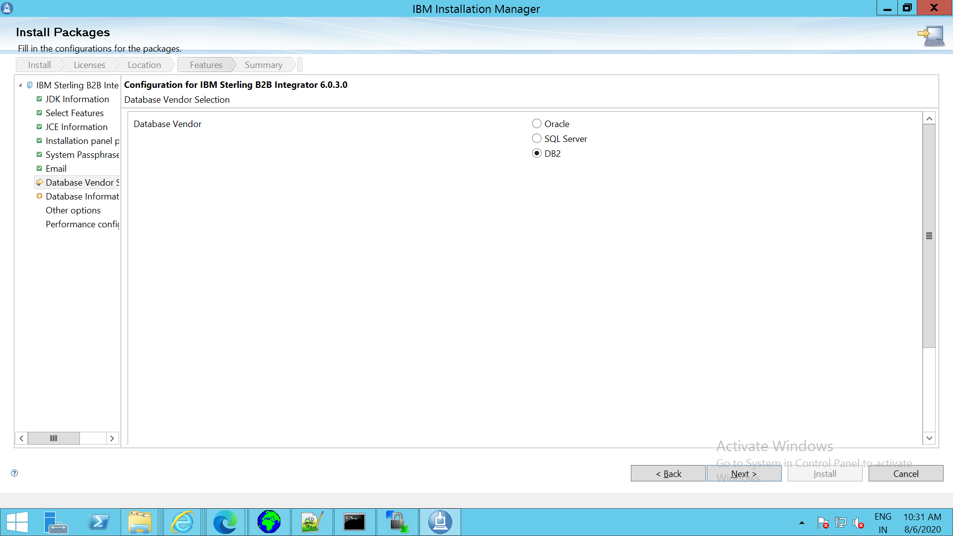

+++++++++++++++++++++++++++++++++++++++++++++++++++++++++++++++++++++++++++++++++++

1. Enter the database information and Test the connection

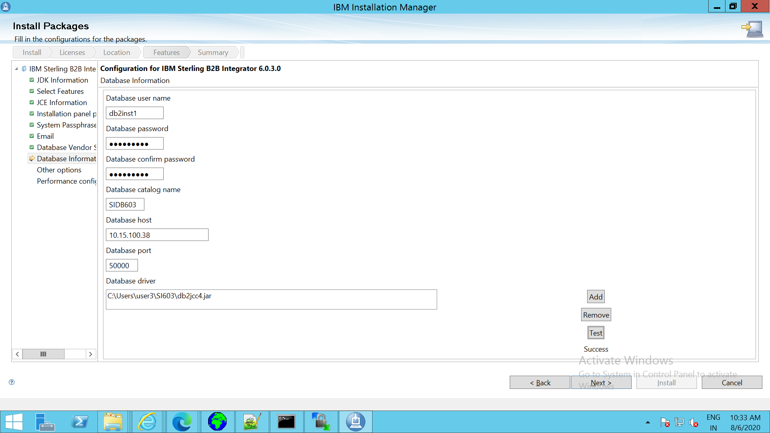

+++++++++++++++++++++++++++++++++++++++++++++++++++++++++++++++++++++++++++++++++++

1. Choose Upgrade or Verbose install

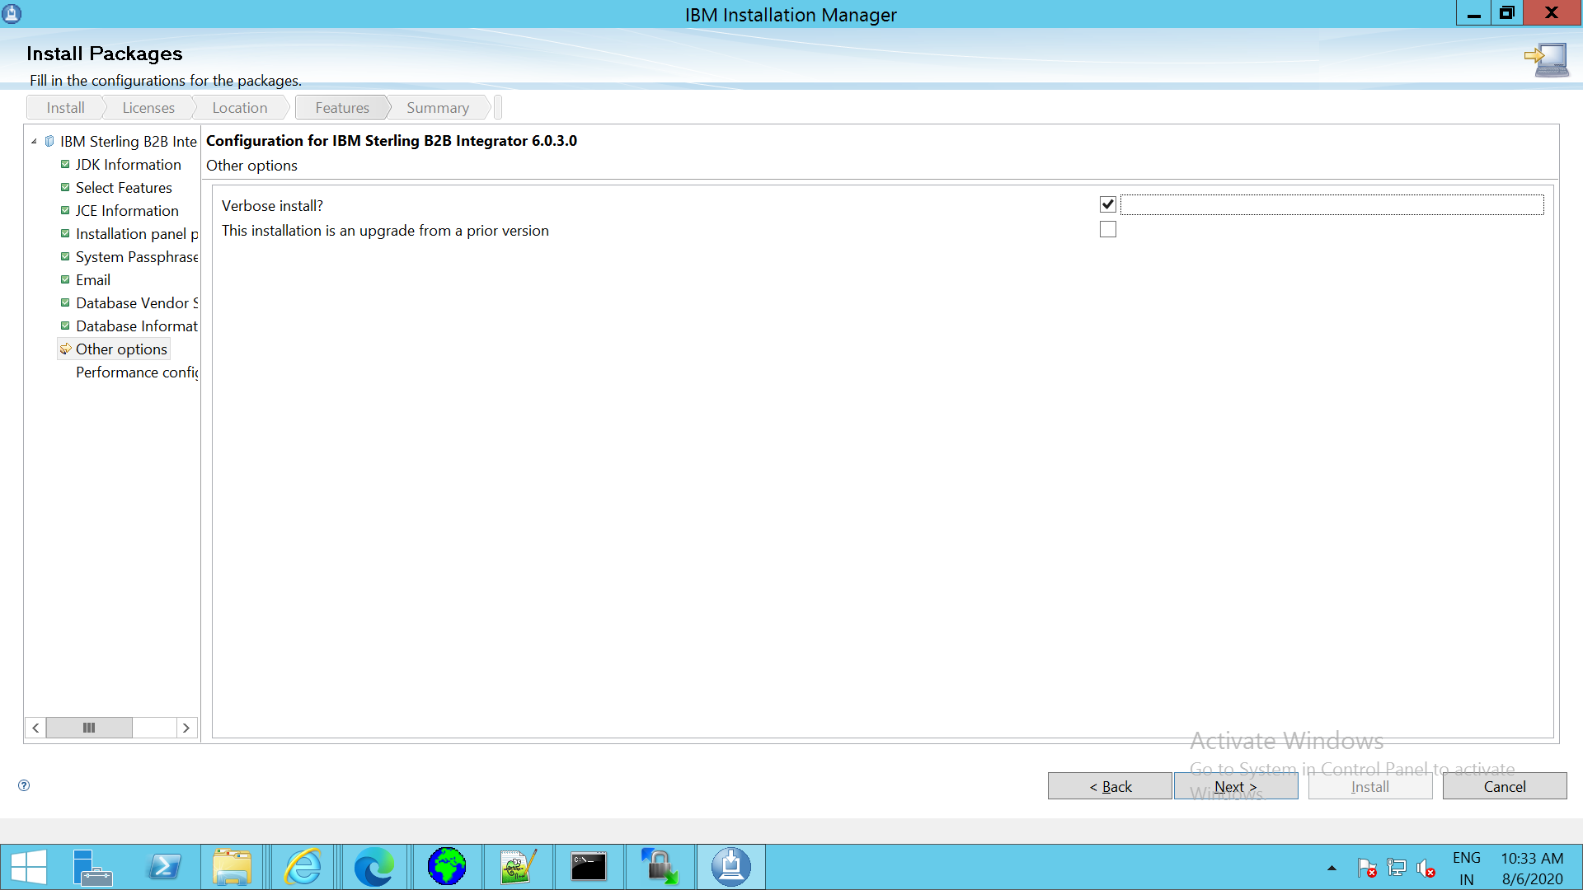

++++++++++++++++++++++++++++++++++++++++++++++++++++++++++++++++++++++++++++++++++++116) Enter Performance configuration or else keep it default value as shown below

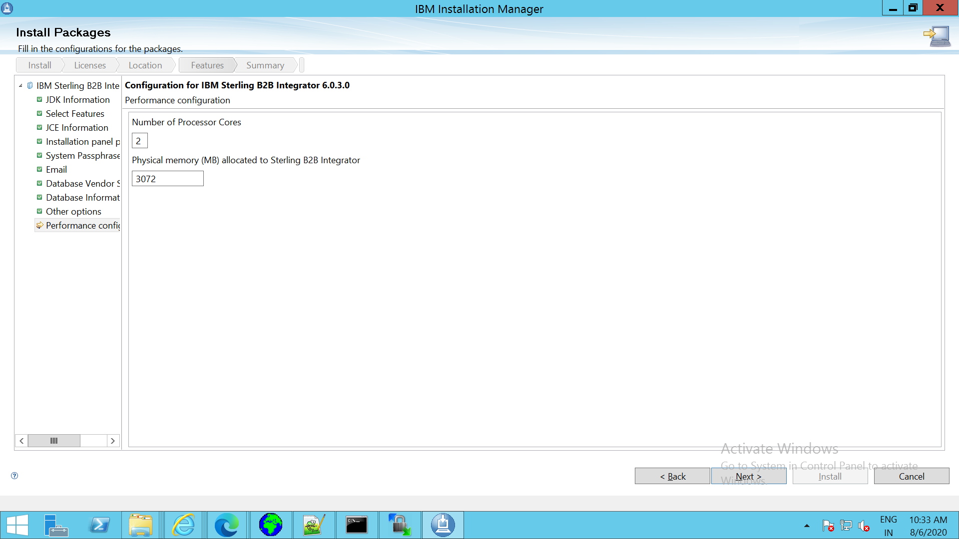

+++++++++++++++++++++++++++++++++++++++++++++++++++++++++++++++++++++++++++++++++++

17)Click on Install

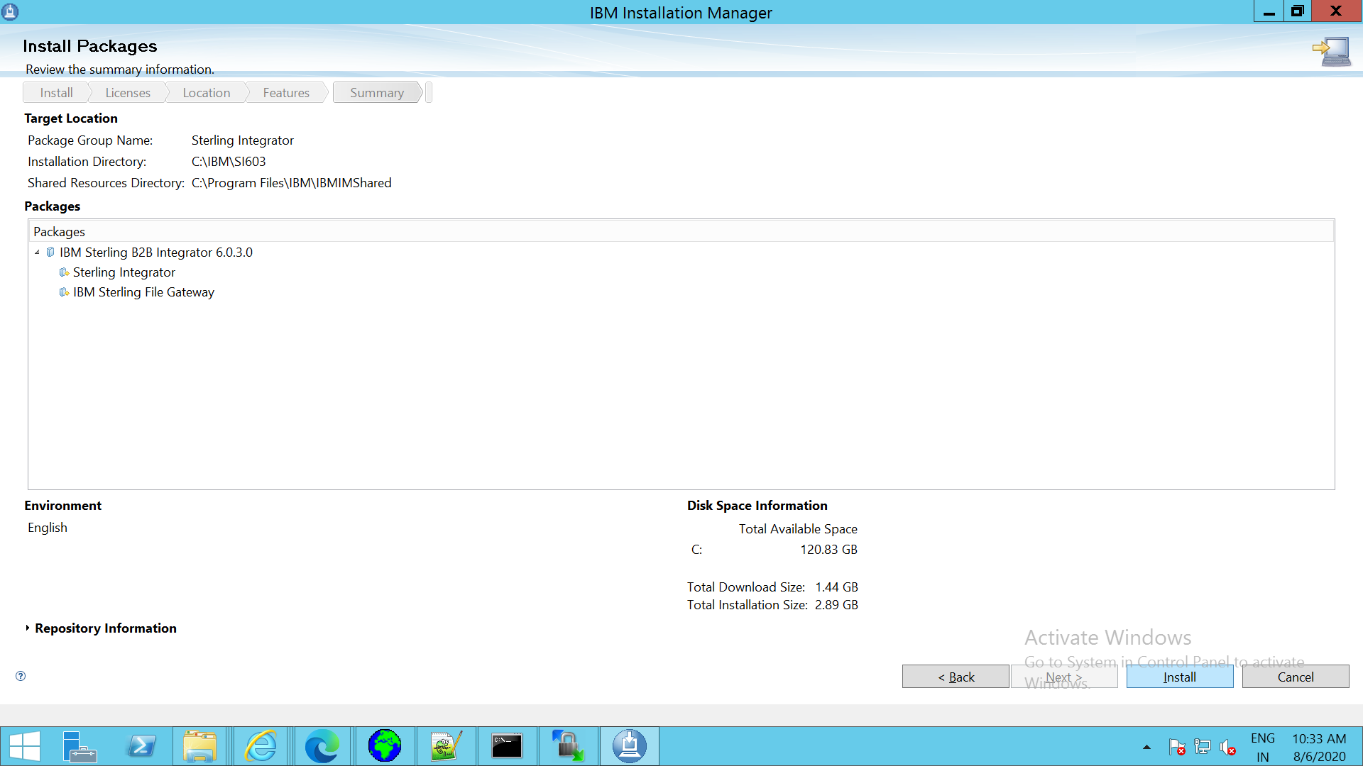

++++++++++++++++++++++++++++++++++++++++++++++++++++++++++++++++++++++++++++++++++++

18) Post installation Click on Finish

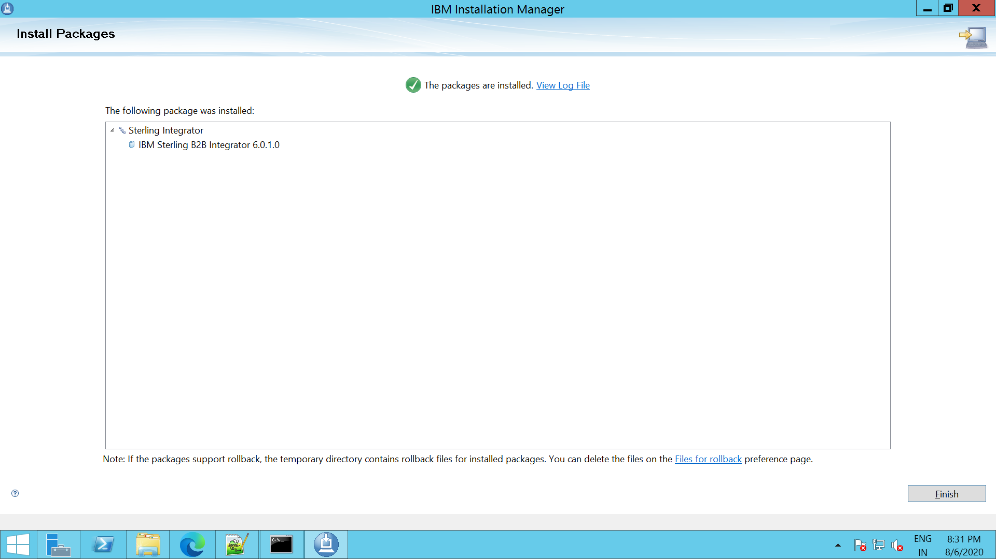

Java 8 installation link

<https://www.ibm.com/support/fixcentral/swg/selectFixes?parent=ibm%7EOther%20software&product=ibm/Other+software/Sterling+B2B+Integrator&release=6.0.3.0&platform=Windows&function=textSearch&text=SDK8SR5FP30>